* ***Soar to your destination with smiles packed into your luggage.***

**AirLink InfoTech**

**Adithyan Pratheeksh Nair**

**&**

**Ryan Jomy Valavi**

**SYNOPSIS OF THE PROJECT**

**Aim:**

**The project aims to mimic the working of a database management software of a particular company.**

**Objective:**

**To obtain data from the user and perform several functions with it using a well-defined set of algorithms.**

**Description:**

**Airlink Infotech is a ticketing agency. The essence of this project is the process by which this company maintains its database of records containing the information of its employees as well as the ticket transaction data which are optimized into MySQL tables.**

**Employee and sales data are inputted into MySQL tables. These records can be updated, deleted, analyzed and compared with the other records in the table.**

**The code is designed in such a way that it accommodates two sections of this company namely the sales and the HR department. It gives complete freedom to all the employees falling under the HR department to modify, delete and update data pertaining to all the employees.**

**Another table is created containing the data of all the transactions made through this firm. This can only be accessed by the sales department of this company. The data from this is used to compare the sales of different flights, modify the data if needed, track particular transactions and graphically analyze the growth of various flights through the course of the year.**

**Thus, this software can be used by a company to provide a systematic approach to sort, alter and analyze the bulk of data a company like a ticketing agency receives on a daily basis.**

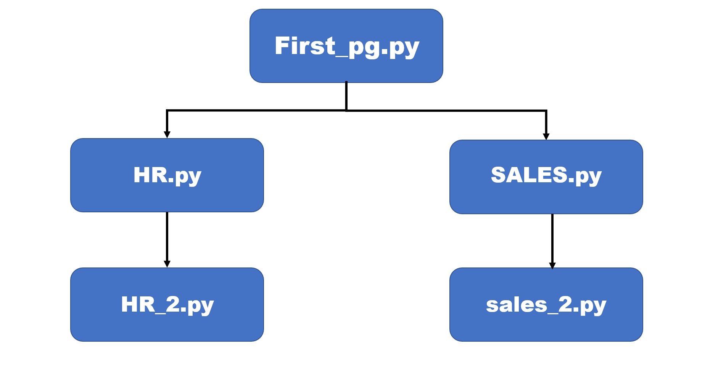**Program Flowchart:**

**CONCEPTS USED:**

* **MySQL**
* **Python-MySQL connectivity**
* **Iterations and Conditional statements**
* **Data Structures-Lists, Dictionaries**
* **User Interface Creation-Tkinter**
* **Python Modules and Libraries**

**PROGRAM CODE:**

**First_pg.py**

from tkinter import *

from tkinter import messagebox

import mysql.connector as c

con=c.connect(host='localhost',user='root',passwd='ryansheenu2003',database='airinfo')

x=con.cursor()

**#CREATING TKINTER WINDOW**

main=Tk()

main.state('zoomed')

main.config(bg='#191970')

b1=Button(main,text='AirLink InfoTech',font=('Times Roman Bold',60))

b1.pack(pady=100)

**#COMMAND FOR NEXT PAGE**

def _1():

def nxt():

u=user.get()

p=passw.get()

query='select emp_no from salespass where usern="{}" and passw="{}"'.format(u,p)

query1='select emp_no from hrpass where usern="{}" and passw="{}"'.format(u,p)

x.execute(query)

f=x.fetchone()

x.execute(query1)

g=x.fetchone()

if u=='': **#IF USERNAME IS NOT ENTERED**

messagebox.showerror('Error','Invalid username')

elif p=='': **#IF PASSWORD IS NOT ENTERED**

messagebox.showerror('Error','Invalid password')

elif f==None and g==None:

messagebox.showerror('Error','Incorrect Username or Password')

else:

user_label.destroy(),user.destroy(),pass_label.destroy()

passw.destroy(),btn.destroy()

**#COMMAND FOR HR PAGE**

def hr_pg():

m.destroy()

import HR **#IMPORTING HR.py**

**#COMMAND FOR SALES PAGE**

def sales_pg():

m.destroy()

import Sales **#IMPORTING Sales.py**

Label(m,text='SELECT DEPARTMENT',fg='white',bg='#191970',font=('',50)).pack()

Button(m,text="HR",command=hr_pg,font=('',40),relief='solid').pack(ipadx=130,pady=150)

Button(m, text="Sales",command=sales_pg,font=('',40),relief='solid').pack(ipadx=100)

main.destroy()

m=Tk()

m.state('zoomed')

m.config(bg='#191970')

user_label=Label(m,text='USERNAME',fg='white',bg='#191970',font=('','20'))

user_label.pack(pady=30)

user=Entry(m,font=('',20))

user.pack(padx=50)

pass_label=Label(m,text='PASSWORD',fg='white',bg='#191970',font=('',20))

pass_label.pack(pady=30)

passw=Entry(m,font=('','20'),show='*')

passw.pack()

btn=Button(m,text='NEXT',font=('',40),relief='solid',command=nxt)

btn.pack(pady=30)

m.mainloop()

**#COMMAND TO QUIT THE PROGRAM**

def quit_pg():

mb=messagebox.askquestion('quit','Are you sure that you want to quit')

if mb=='yes':

main.destroy()

**#CREATING BUTTONS**

b2=Button(main,text='ENTER',font=('',30),command=_1,relief='solid')

b2.place(relx=0.85,rely=0.8)

b3=Button(main,text='QUIT',font=('',30),command=quit_pg,relief='solid')

b3.place(rely=0.8,relx=0.03)

main.mainloop()

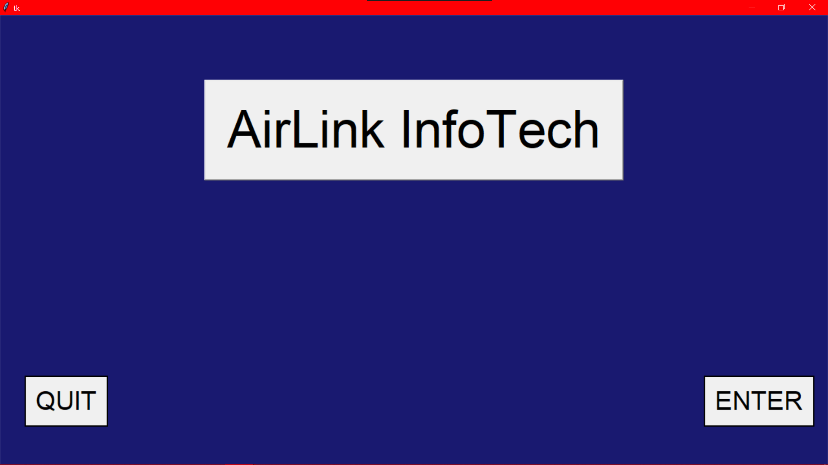

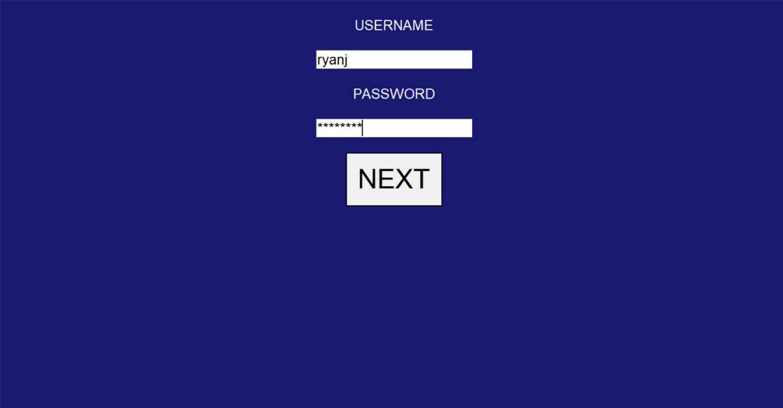

**HR.py**

from tkinter import *

from tkinter import messagebox,ttk

import mysql.connector as c

hr=Tk()

hr.state('zoomed')

hr.config(bg='#191970')

con=c.connect(host='localhost',user='root',passwd='ryansheenu2003',database='airinfo')

x=con.cursor()

#back

def back():

hr.destroy()

from First_pg import _1

#Username

user_label=Label(hr,text='USERNAME',fg='white',bg='#191970',font=('',25))

user_label.pack(pady=30)

user=Entry(hr,font=('',30))

user.pack(padx=50)

#password

pass_label=Label(hr,text='PASSWORD',fg='white',bg='#191970',font=('',25))

pass_label.pack(pady=30)

passw=Entry(hr,font=('',30),show='*')

passw.pack()

#next page

def check():

n=user.get() **#USERNAME**

p=passw.get() **#PASSWORD**

if n=='': **#IF USERNAME IS NOT ENTERED**

messagebox.showerror('Error','Invalid username')

elif p=='': **#IF PASSWORD IS NOT ENTERED**

messagebox.showerror('Error','Invalid password')

else:

query='select * from hrpass where usern="{}" and passw="{}"'.format(n,p)

x.execute(query)

y=x.fetchone()

if y==None: **#IF USERNAME OR PASSWORD DOESN'T EXIST IN TABLE**

messagebox.showerror('Error','Incorrect Username or Password')

else:

hr.destroy()

import HR_2 **#IMPORTING HR_2.py**

submit_btn=Radiobutton(hr,text='SUBMIT',font=('',20),command=check,relief='solid')

submit_btn.pack(side='right',pady=10,ipady=30)

back_btn=Radiobutton(hr,text=' HOME ',font=('',20),command=back,relief='solid')

back_btn.pack(side='left',pady=10,ipady=30)

hr.mainloop()

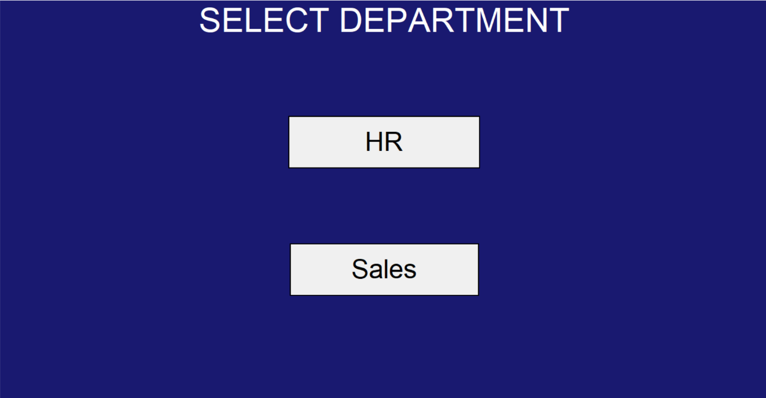

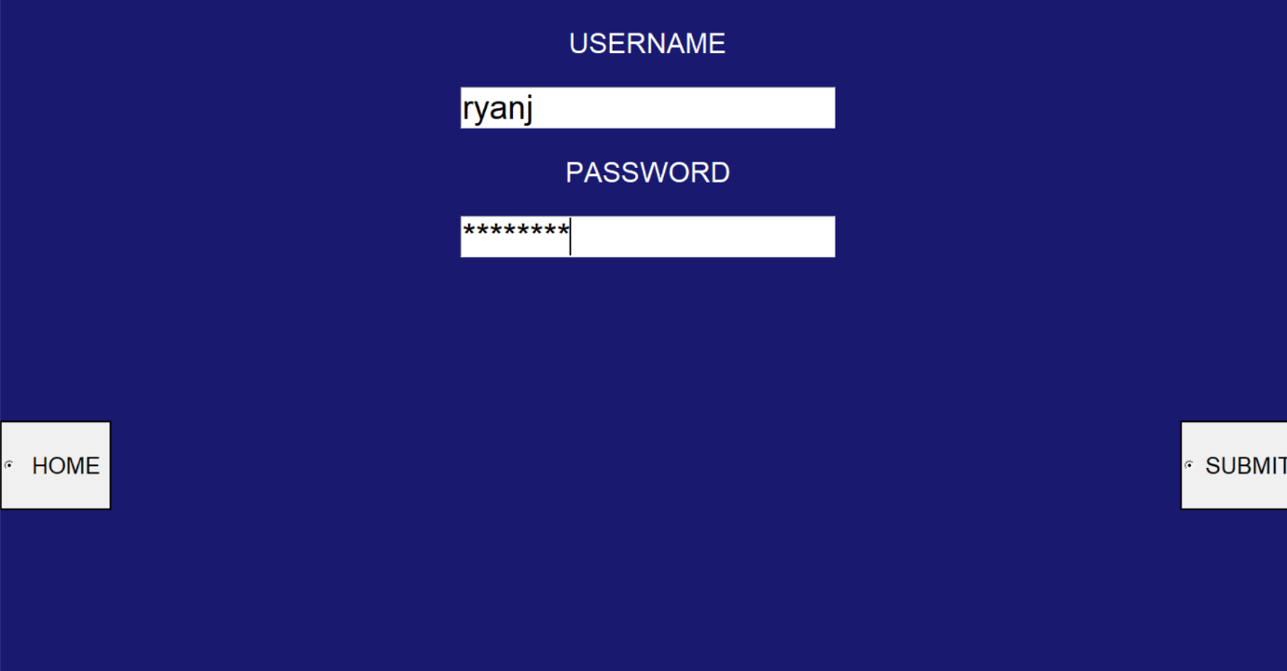

**HR_2.py**

from tkinter import *

from tkinter import ttk,messagebox

import mysql.connector as c

**#CONNECTING MYSQL**

con=c.connect(host='localhost',user='root',passwd='ryansheenu2003',database='airinfo')

x=con.cursor()

**#CREATING NEW WINDOW**

HR=Tk()

HR.state('zoomed')

HR.config(bg='#191970')

**#TO EXIT THE PROGRAM**

def end():

mb=messagebox.askquestion('quit','Are you sure that you want to quit')

if mb=='yes':

HR.destroy()

**#COMMAND TO GO BACK**

def home():

HR.destroy()

import sec_pg **#IMPORTING sec_pg.py**

def nxt():

ch=lb.index(lb.curselection())

def bck():

hr.destroy()

HR.state('zoomed')

**#TO ADD AN EMPLOYEE**

if ch==0:

def nxt():

def submit():

u=usern.get() **#USERNAME**

p=passw.get() **#PASSWORD**

if u=='': **#IF NOTHING IS ENTERED**

messagebox.showerror('Error','Username not entered')

elif p=='':

messagebox.showerror('Error','Password not entered')

else:

if dpt=="hr":

query2="insert into hrpass values('{}','{}','{}')".format(emp_id,u,p)

x.execute(query2)

con.commit() **#INSERTING THE DATA INTO HRPASS TABLE**

elif dpt=='sales':

query3="insert into salespass values('{}','{}','{}')".format(emp_id,u,p)

x.execute(query3)

con.commit() **#INSERTING THE DATA INTO SALESPASS TABLE**

mb=messagebox.showinfo('','Added successfully')

HR.state('zoomed')

emp_id=empid.get() **#EMPLOYEE ID**

emp_nm=empnm.get() **#EMPLOYEE NAME**

dpt=(dept.get()).lower() **#DEPARTMENT**

sly=sal.get() **#SALARY**

j="select emp_no from employee where emp_no='{}'".format(emp_id)

x.execute(j)

k=x.fetchone()

if k!=None or emp_id=='': **#IF EMPLOYEE ID IS NOT ENTERED OR ALREADY EXIST IN EMPLOYEE TABLE**

messagebox.showerror('Error','Invalid Employee ID')

elif emp_nm=='': **#IF EMPLOYEE NAME IS NOT ENTERED**

messagebox.showerror('Error','Invalid Employee Name')

elif sly=='': **#IF SALARY IS NOT ENTERED**

messagebox.showerror('Error','Invalid Salary')

elif dpt not in ('hr','sales'): **#IF DEPARTMENT ENTERED IS NEITHER HR NOR SALES**

messagebox.showerror('Error','Invalid Department')

else:

query1="insert into employee values('{}','{}','{}',{})".format(emp_id,emp_nm,dpt,int(sly))

x.execute(query1)

con.commit()

LABEL.destroy(),empid_label.destroy(),empnm_label.destroy(),dept_label.destroy(),sal_label.destroy()

empid.destroy(),empnm.destroy(),dept.destroy(),sal.destroy(),nxt.destroy()

usern_label=Label(hr,text='Username',fg='white',bg='#191970',font=('',25))

usern_label.place(relx=0.025,rely=0.15)

usern=Entry(hr,font=('',22))

usern.pack(anchor='ne',padx=20,pady=95)

passw_label=Label(hr,text='Password',fg='white',bg='#191970',font=('Times Roman',25))

passw_label.place(relx=0.027,rely=0.34)

passw=Entry(hr,font=('',22),show='*')

passw.pack(anchor='ne',padx=20)

add=Button(hr,text='ADD',font=('',40),command=submit,relief='solid')

add.place(relx=0.85,rely=0.8)

HR.state('withdraw')

hr=Tk()

hr.state('zoomed')

hr.config(bg='#191970')

LABEL=Label(hr,text='ADD EMPLOYEE',fg='white',bg='#191970',font=('',40))

LABEL.place(x=0,y=0,relwidth=1)

empid_label=Label(hr,text='Employee Id',fg='white',bg='#191970',font=('',25))

empid_label.place(relx=0.025,rely=0.15)

empid=Entry(hr,font=('',30))

empid.pack(anchor='nw',padx=350,pady=95)

empnm_label=Label(hr,text='Name of employee',fg='white',bg='#191970',font=('',25))

empnm_label.place(relx=0.027,rely=0.34)

empnm=Entry(hr,font=('',30))

empnm.pack(anchor='nw',padx=350)

sal_label=Label(hr,text='Salary',fg='white',bg='#191970',font=('',25))

sal_label.place(relx=0.0325,rely=0.55)

sal=Entry(hr,font=('',30))

sal.pack(anchor='nw',padx=350,pady=95)

dept_label=Label(hr,text='Department',fg='white',bg='#191970',font=('',25))

dept_label.place(relx=0.04,rely=0.775)

l=['HR','Sales']

txt=StringVar()

dept=ttk.Combobox(hr,textvariable=txt,font=('',30))

dept['values']=l

dept.current(0)

dept.pack(anchor='nw',padx=350)

nxt=Button(hr,text='NEXT',font=('',40),command=nxt,relief='solid')

nxt.place(relx=0.85,rely=0.85)

back=Button(hr,text='BACK',font=('',40),command=bck,relief='solid')

back.place(relx=0.02,rely=0.85)

**#Deleting an existing employee**

if ch==1:

def submit():

emp_id=empid.get()

dpt=(dept.get()).lower()

j="select emp_no from employee where emp_no='{}'".format(emp_id)

x.execute(j)

k=x.fetchone()

if k==None or emp_id=='': **#IF EMPLOYEE ID IS NOT ENTERED OR ALREADY EXIST IN EMPLOYEE TABLE**

messagebox.showerror('Error','Invalid Employee ID')

elif dpt not in ('hr','sales'):

messagebox.showerror('Error','Invalid Department')

else:

if dpt=="hr":

query="delete from hrpass where emp_no='{}'".format(emp_id)

x.execute(query)

con.commit()

query1="delete from employee where emp_no='{}'".format(emp_id)

x.execute(query1)

con.commit()

mb=messagebox.showinfo('','Deleted successfully')

elif dpt=='sales':

query="delete from salespass where emp_no='{}'".format(emp_id)

x.execute(query)

con.commit()

query1="delete from employee where emp_no='{}'".format(emp_id)

x.execute(query1)

con.commit()

mb=messagebox.showinfo('','Deleted successfully')

HR.state('withdraw')

hr=Tk()

hr.state('zoomed')

hr.config(bg='#191970')

LABEL=Label(hr,text='DELETE EMPLOYEE',fg='white',bg='#191970',font=('Times Roman',40))

LABEL.place(x=0,y=0,relwidth=1)

empid_label=Label(hr,text='Employee Id',fg='white',bg='#191970',font=('Times Roman',25))

empid_label.place(relx=0.025,rely=0.15)

empid=Entry(hr,font=('',30))

empid.pack(anchor='nw',padx=350,pady=95)

dept_label=Label(hr,text='Department',fg='white',bg='#191970',font=('Times Roman',25))

dept_label.place(relx=0.0325,rely=0.5)

l=['HR','Sales']

txt=StringVar()

dept=ttk.Combobox(hr,textvariable=txt,font=('',30))

dept['values']=l

dept.current(0)

dept.pack(anchor='nw',padx=350,pady=95)

delete=Button(hr,text='DELETE',font=('',40),command=submit,relief='solid')

delete.place(relx=0.8,rely=0.8)

back=Button(hr,text='BACK',font=('',40),command=bck,relief='solid')

back.place(relx=0.02,rely=0.8)

**#Displaying the employee database**

if ch==2:

hr=Tk()

hr.state('zoomed')

L=Label(hr,text='EMPLOYEE DATABASE',font=('',40))

L.place(relwidth=1)

L1=Label(hr,text='Employee ID',font=('',40),borderwidth=2,relief='solid')

L1.place(rely=0.1,relx=0.01,relwidth=0.24)

L2=Label(hr,text='Name',font=('',40),borderwidth=2,relief='solid')

L2.place(rely=0.1,relx=0.251,relwidth=0.3)

L3=Label(hr,text='Department',font=('',40),borderwidth=2,relief='solid')

L3.place(rely=0.1,relx=0.5515,relwidth=0.27)

L4=Label(hr,text='Salary',font=('',40),borderwidth=2,relief='solid')

L4.place(rely=0.1,relx=0.823,relwidth=0.165)

query="select * from employee order by name"

x.execute(query)

j=0.2

for k in x:

l1=Label(hr,text=k[0],font=('',30),borderwidth=2,relief='solid')

l1.place(rely=j,relx=0.01,relwidth=0.24)

l2=Label(hr,text=k[1],font=('',30),borderwidth=2,relief='solid')

l2.place(rely=j,relx=0.251,relwidth=0.3)

l3=Label(hr,text=k[2],font=('',30),borderwidth=2,relief='solid')

l3.place(rely=j,relx=0.5515,relwidth=0.27)

l4=Label(hr,text=k[3],font=('',30),borderwidth=2,relief='solid')

l4.place(rely=j,relx=0.823,relwidth=0.165)

j+=0.08

**#Updating the salary package of a particular employee**

if ch==3:

def submit():

emp_id=empid.get()

sly=sal.get()

j="select emp_no from employee where emp_no='{}'".format(emp_id)

x.execute(j)

k=x.fetchone()

if emp_id=='' or k==None: **#IF EMPLOYEE ID IS NOT ENTERED OR ALREADY EXIST IN EMPLOYEE TABLE**

messagebox.showerror('Error','Invalid Employee ID')

elif sly=='':

messagebox.showerror('Error','Invalid Salary')

else:

query="update employee set Salary={} where emp_no='{}'".format(int(sly),emp_id)

x.execute(query)

con.commit()

mb=messagebox.showinfo('','Upadated successfully')

HR.state('withdraw')

hr=Tk()

hr.state('zoomed')

hr.config(bg='#191970')

LABEL=Label(hr,text='UPDATE SALARY OF EMPLOYEE',fg='white',bg='#191970',font=('Times Roman',40))

LABEL.place(x=0,y=0,relwidth=1)

empid_label=Label(hr,text='Employee Id',fg='white',bg='#191970',font=('',25))

empid_label.place(relx=0.025,rely=0.15)

empid=Entry(hr,font=('',30))

empid.pack(anchor='nw',padx=350,pady=95)

sal_label=Label(hr,text='New Salary',fg='white',bg='#191970',font=('',25))

sal_label.place(relx=0.04,rely=0.35)

sal=Entry(hr,font=('',30))

sal.pack(anchor='nw',padx=350)

Button(hr,text='UPDATE',font=('',40),command=submit,relief='solid').place(relx=0.75,rely=0.8)

back=Button(hr,text='BACK',font=('',40),command=bck,relief='solid')

back.place(relx=0.02,rely=0.8)

**#MAIN**

label=Label(HR,text='SELECT FUNCTION',fg='white',bg='#191970',font=('',40))

label.pack()

lb=Listbox(HR,font=('',40),relief='solid')

lb.place(rely=0.2,relx=0.25,relheight=0.4)

lb.insert(0,' Add employee')

lb.insert(1,' Remove employee')

lb.insert(3," Update salary package")

lb.insert(2,' Display all employees')

slc=Button(HR,text='SELECT',font=('',30),command=nxt,relief='solid')

slc.place(relx=0.85,rely=0.8)

back=Button(HR,text='HOME',font=('',30),command=home,relief='solid')

back.place(rely=0.8,relx=0.03,relwidth=0.12)

Quit=Button(HR,text='QUIT',font=('',30),command=end,relief='solid')

Quit.place(rely=0.8,relx=0.4,relwidth=0.12)

HR.mainloop()

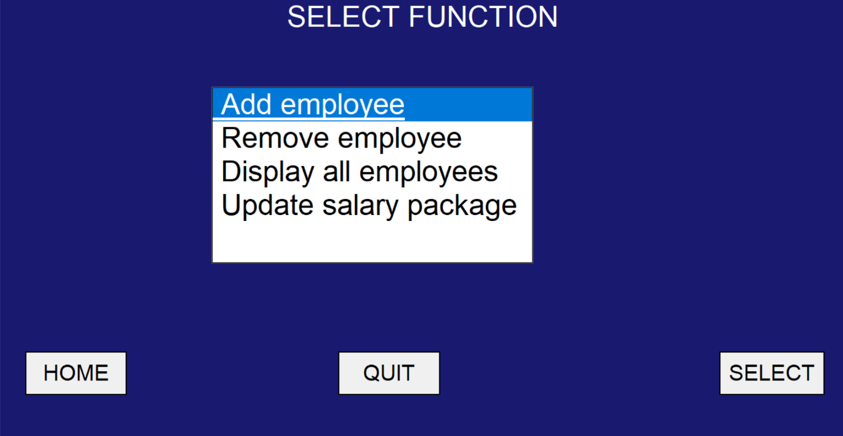

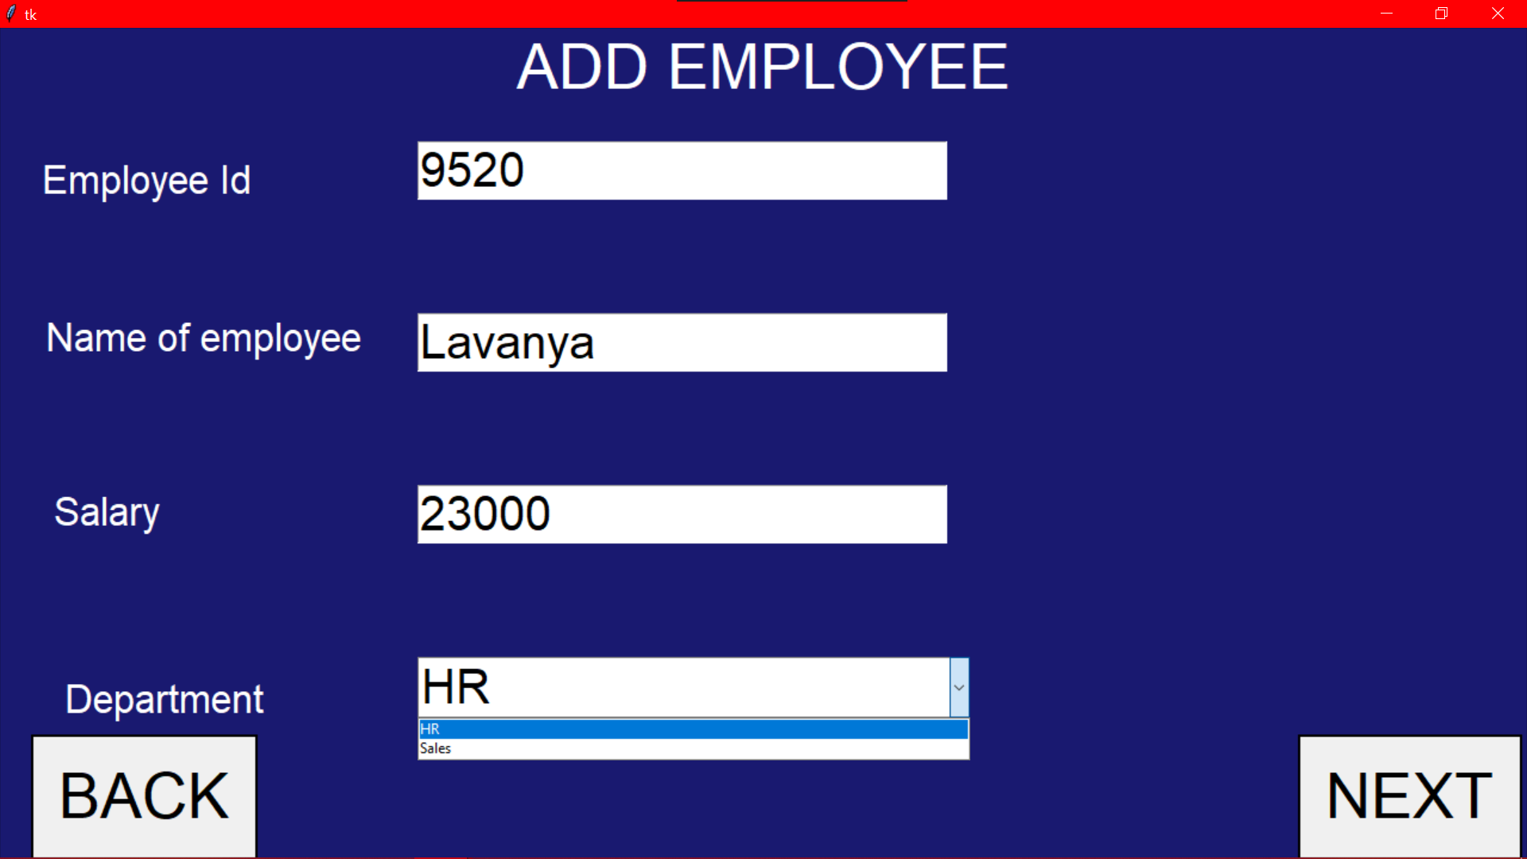

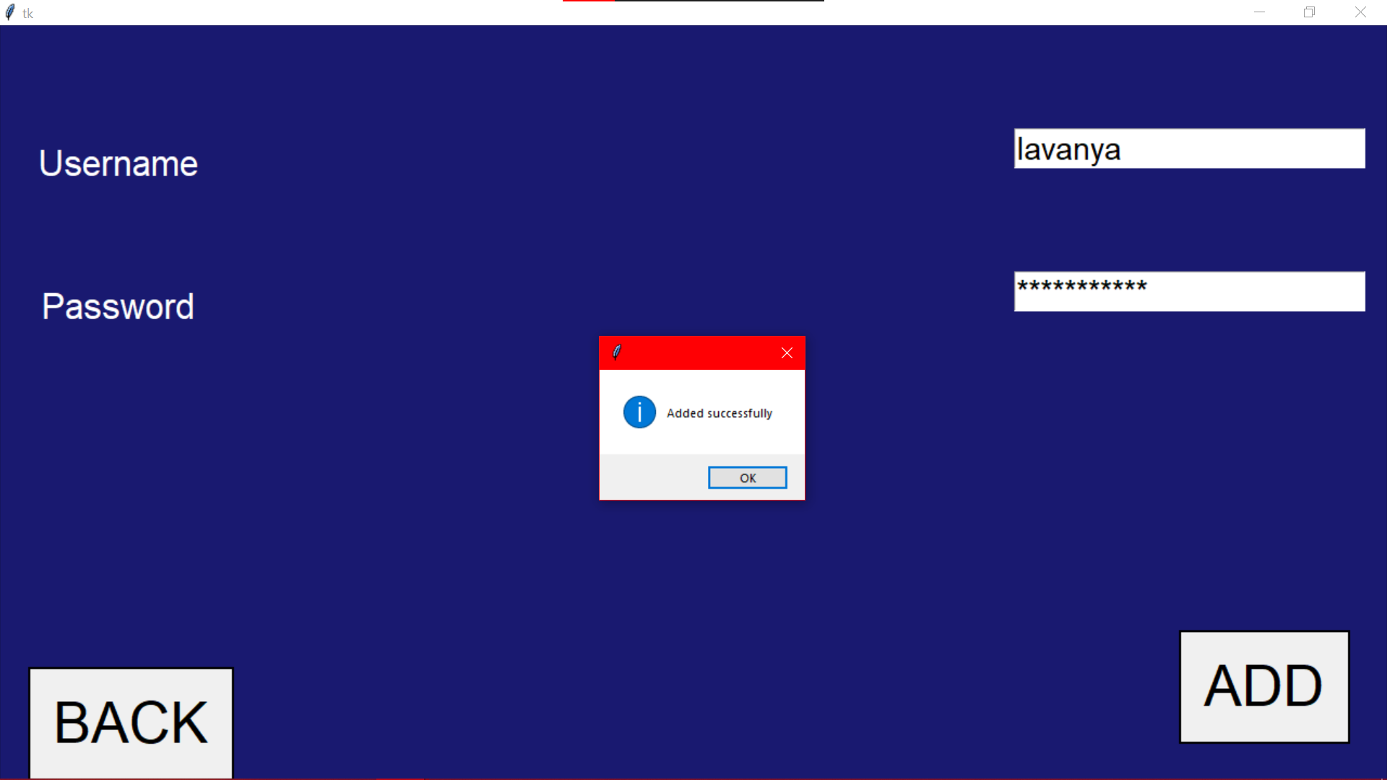

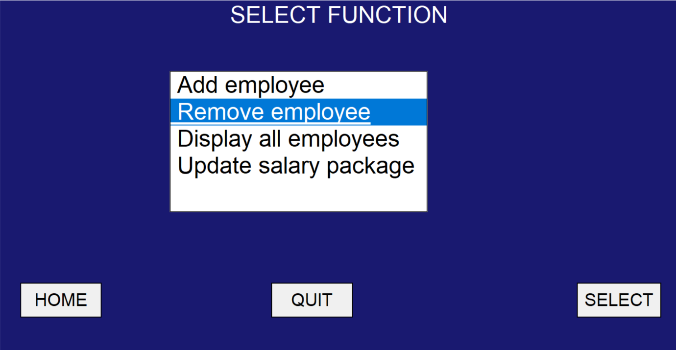

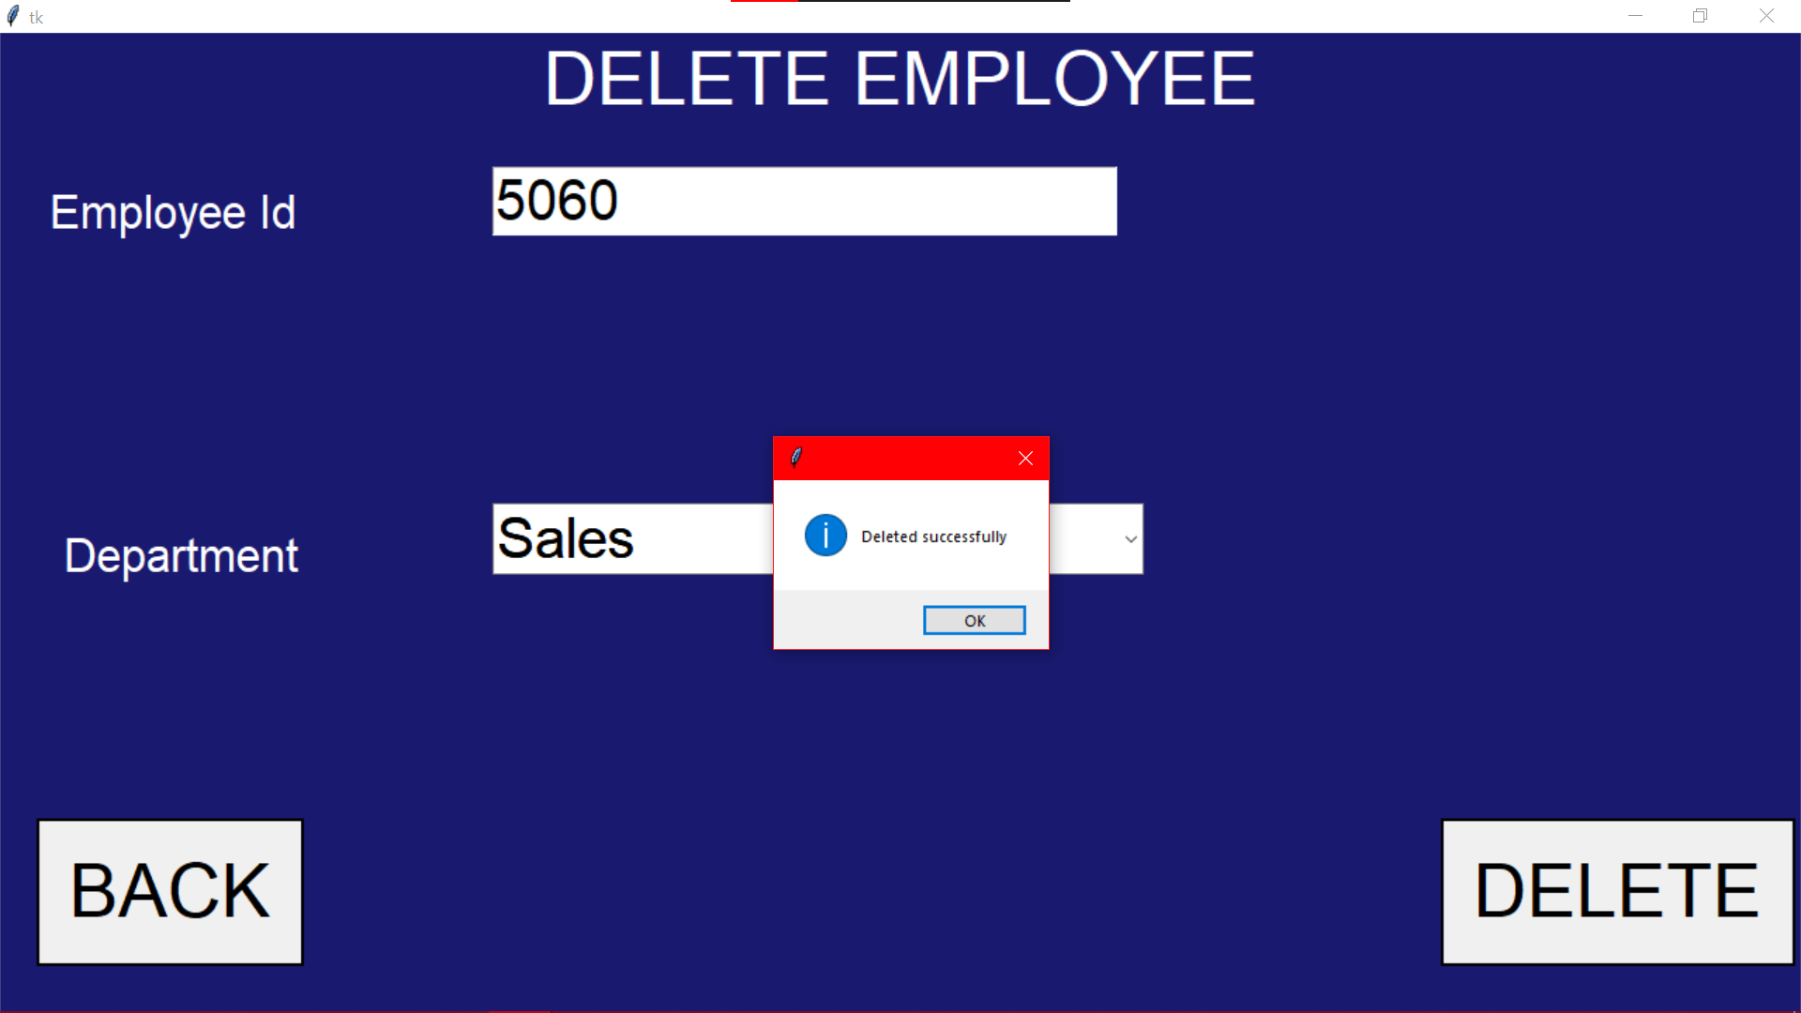

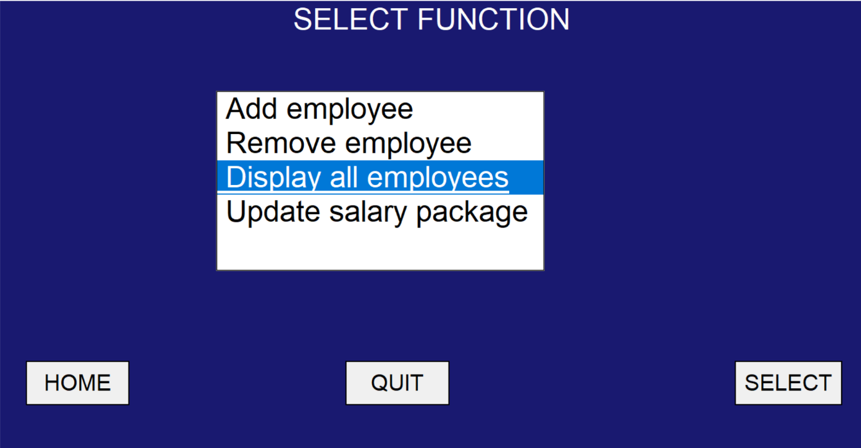

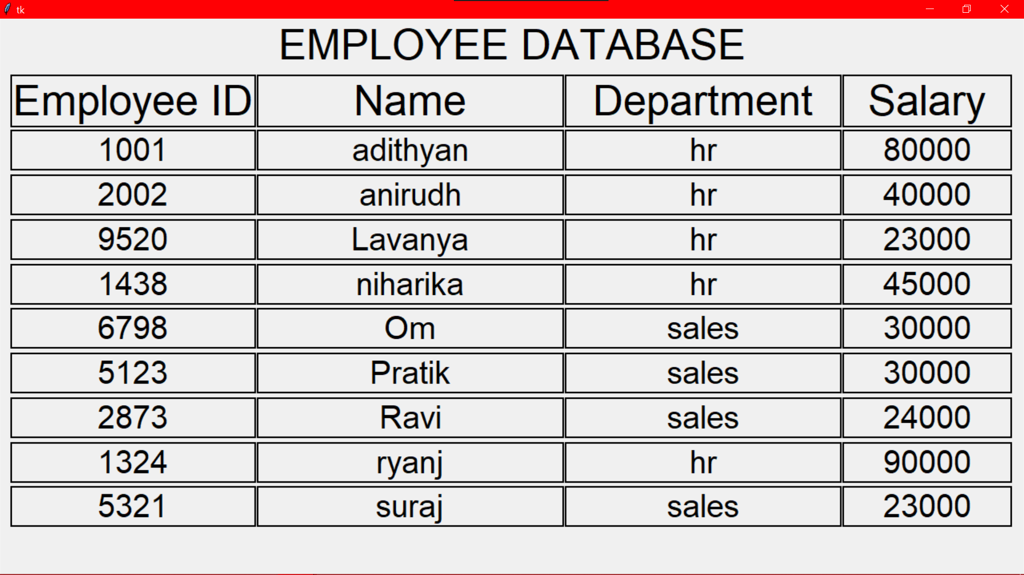

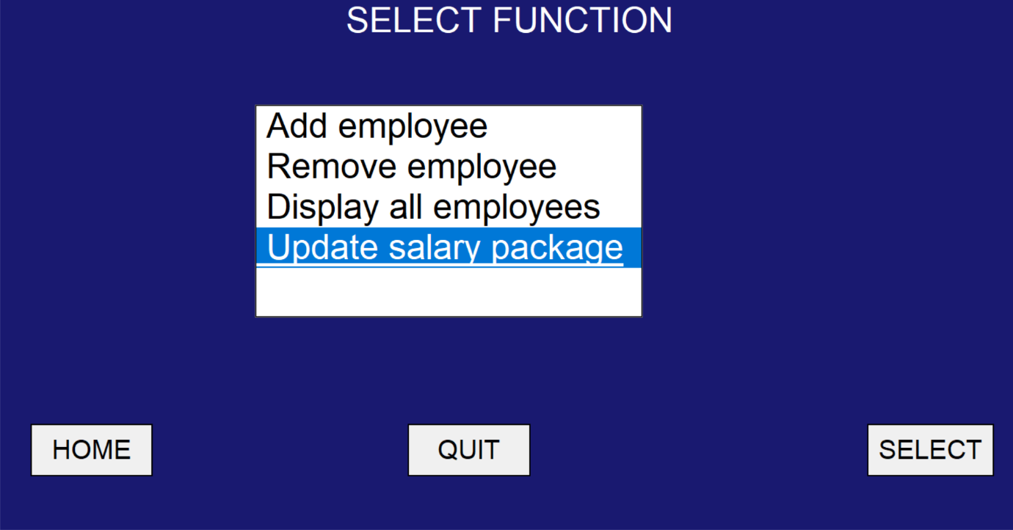

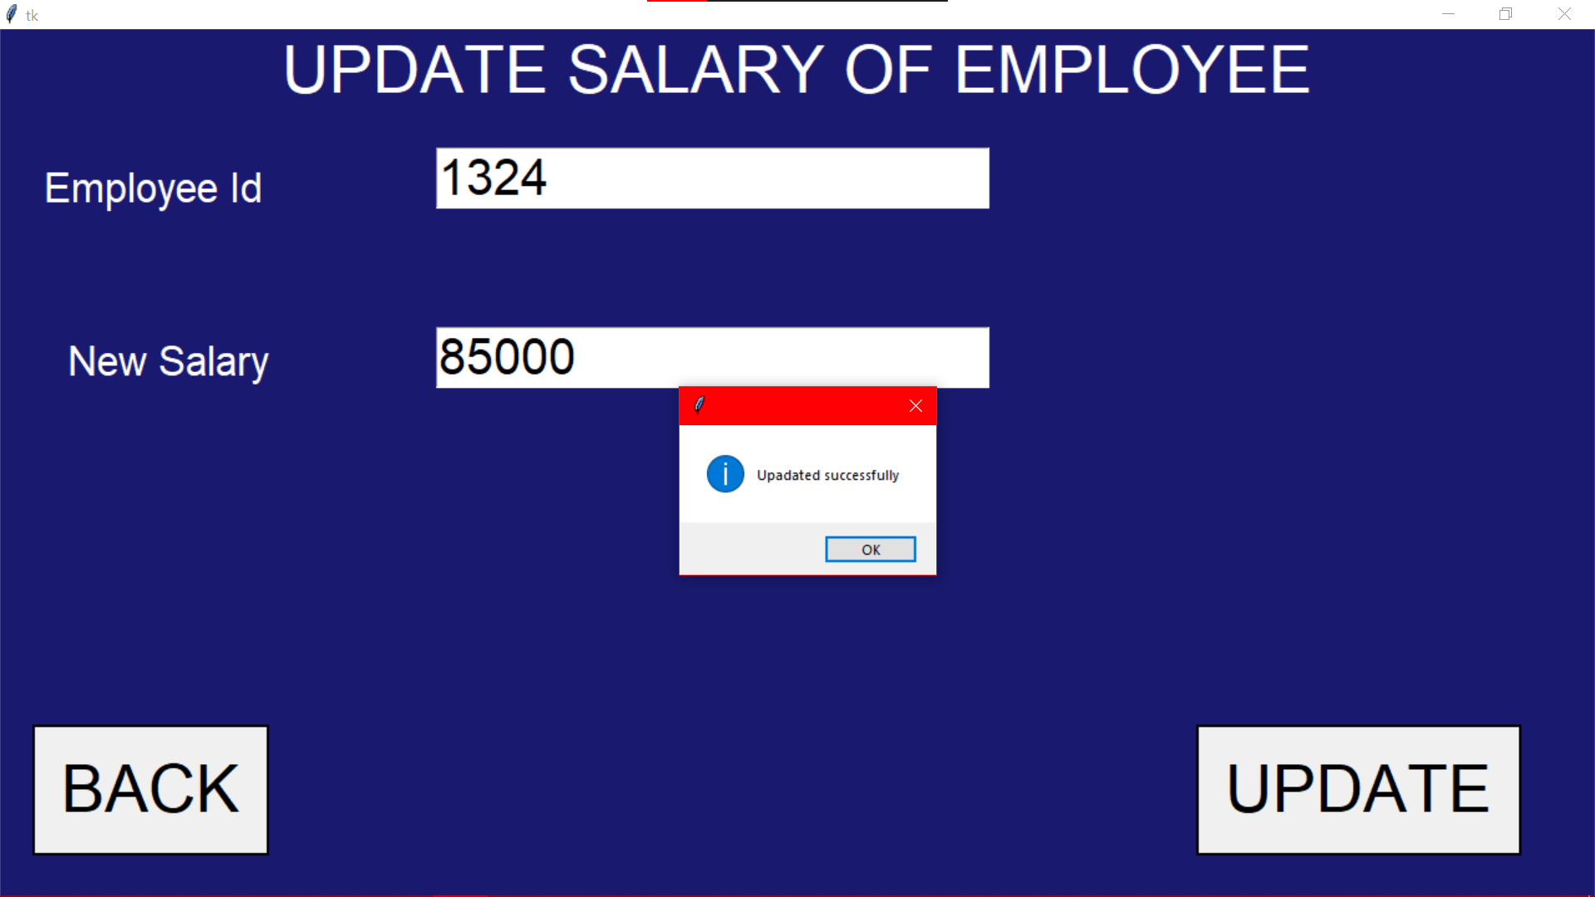

**Sales.py**

from tkinter import *

from tkinter import messagebox,ttk

from tkcalendar import Calendar

import mysql.connector as c

con=c.connect(host='localhost',user='root',passwd='ryansheenu2003',database='airinfo')

x=con.cursor()

SALES=Tk()

SALES.config(bg='#191970')

def back():

SALES.destroy()

import First_pg

SALES.state('zoomed')

user_label=Label(SALES,text='USERNAME',fg='white',bg='#191970',font=('Times Roman','20'))

user_label.pack(pady=30)

user=Entry(SALES,font=('','20'))

user.pack(padx='50')

pass_label=Label(SALES,text='PASSWORD',fg='white',bg='#191970',font=('Times Roman','20'))

pass_label.pack(pady=30)

passw=Entry(SALES,font=('','20'),show='*')

passw.pack()

def check():

n=user.get()

p=passw.get()

query='select * from salespass where usern="{}" and passw ="{}"'.format(n,p)

x.execute(query)

y=x.fetchone()

if n=='' or y==None:

messagebox.showwarning('Error','Invalid Username')

elif p=='':

messagebox.showerror('Error','Invalid Password')

else:

import sales_2

r1=Radiobutton(SALES,text='SUBMIT',font=('',30),command=check,relief='solid')

r1.pack(side='right',pady=30,padx=10)

r2=Radiobutton(SALES,text=' HOME ',font=('',30),command=back,relief='solid')

r2.pack(side='left',pady=30,padx=10)

SALES.mainloop()



**sales_2.py**

from tkinter import *

from tkinter import ttk,messagebox

from tkcalendar import Calendar

import graphit

import mysql.connector as c

con=c.connect(host='localhost',user='root',passwd='ryansheenu2003',database='airinfo')

x=con.cursor()

SALEs=Tk()

SALEs.config(bg='#191970')

SALEs.state('zoomed')

**#TO EXIT THE PROGRAM**

def end():

mb=messagebox.askquestion('quit','Are you sure that you want to quit')

if mb=='yes':

SALEs.destroy()

def _0():

def nxt():

t=trans_no.get()

f=flt.get()

i=inc.get()

def submit():

d=date.get_date()

query="select transacnr from sales where transacnr='{}'".format(t)

x.execute(query)

e=x.fetchone()

if e!=None or t=='':

messagebox.showerror('Error','Transaction no not entered')

elif f=='':

messagebox.showerror('Error','Flight Name not entered')

elif i=='':

messagebox.showerror('Error','Amount received after transaction not entered')

elif d=='':

messagebox.showerror('Error','Date not entered')

else:

query1="insert into sales values('{}','{}','{}',{})".format(t,d,f,i)

x.execute(query1)

con.commit()

S.destroy()

SALEs.state('zoomed')

transno_label.destroy(),trans_no.destroy(),inc_label.destroy()

inc.destroy(),flt_label.destroy(),flt.destroy()

date_label=Label(S,text='Date',fg='white',bg='#191970',font=('',40))

date_label.pack()

date=Calendar(S,selectmode='day',date_pattern='y-mm-dd',font=('',30))

date.pack()

btn.config(text='Submit',command=submit)

SALEs.state('withdraw')

S=Tk()

S.state('zoomed')

S.config(bg='#191970')

transno_label=Label(S,text='Transaction No',fg='white',bg='#191970',font=('',40))

transno_label.place(relx=0.025,rely=0.02)

trans_no=Entry(S,font=('',30))

trans_no.pack(anchor='e',padx=10,pady=30)

inc_label=Label(S,text='Ticket Amount',fg='white',bg='#191970',font=('',40))

inc_label.place(relx=0.025,rely=0.18)

inc=Entry(S,font=('',30))

inc.pack(anchor='e',padx=10,pady=30)

flt_label=Label(S,text='Name of Airline',fg='white',bg='#191970',font=('',40))

flt_label.place(relx=0.025,rely=0.36)

l=['AirIndia','Emirates','FlyDubai']

txt=StringVar()

flt=ttk.Combobox(S,textvariable=txt,font=('',30))

flt['values']=l

flt.current(0)

flt.pack(anchor='e',padx=10,pady=30)

btn=Button(S,text='CONTINUE',font=('',40),command=nxt,relief='solid')

btn.place(rely=0.85,relx=0.4)

**#Modify the sales of a particular transaction number**

def _1():

def submit():

i=inc.get()

t=transacnr.get()

j="select transacnr from sales where transacnr='{}'".format(t)

x.execute(j)

k=x.fetchone()

if i=='':

messagebox.showerror('Error','New Income not entered')

elif t=='' or k==None:

messagebox.showerror('Error','Invalid Transaction No')

else:

query="update sales set SaleAmt={} where TransacNr='{}'".format(i,t)

x.execute(query)

con.commit()

messagebox.showinfo('Success','Modified Successfully')

modify.destroy()

modify=Tk()

modify.state('zoomed')

modify.config(bg='#191970')

l2=Label(modify,text='Modify the Sales of a Particular Transaction Number',font=('',40),fg='white',bg='#191970')

l2.pack(fill='x')

l1=Label(modify,bg='#191970',fg='white',text='Transaction No',font=('Times Roman',40))

l1.place(relx=0.1,rely=0.2)

transacnr=Entry(modify,font=('',22))

transacnr.pack(anchor='ne',padx=100,pady=95)

l3=Label(modify,bg='#191970',fg='white',text='New Income',font=('',40))

l3.place(relx=0.1,rely=0.4)

inc=Entry(modify,font=('',22))

inc.pack(anchor='ne',padx=100)

b=Button(modify,text='SUBMIT',font=('',40),command=submit,relief='solid')

b.pack(side='bottom')

**#Get the total sales of the year of**

**# i.a flight ii.airlink Infotech**

def _2():

sales=Tk()

sales.config(bg='#191970')

sales.state('zoomed')

def flight(): #Of flight

F=Tk()

F.config(bg='#191970')

F.state('zoomed')

def nxt():

f=flt.get()

ye=yer.get()

if f not in ('AirIndia','Emirates','FlyDubai'):

messagebox.showerror('Error','Employee no not entered')

elif ye not in ('2019','2020','2021'):

messagebox.showerror('Error','Employee Name not entered')

else:

l3.destroy(),l1.destroy(),l2.destroy(),b1.destroy(),yer.destroy(),flt.destroy()

query="select SaleAmt from sales where year(DateTransac)='{}' and FlightNm='{}'".format(ye,f)

x.execute(query)

y=x.fetchall()

sum1=0

for i in y:

sum1+=i[0]

L=Label(F,text='The total sales of '+f+' for the year '+ye+' is ₹'+str(sum1),font=('',40),fg='white',bg='#191970')

L.pack(anchor='center')

l3=Label(F,text="Total Sales of an Airline for a Year",font=('Times Roman',40),fg='white',bg='#191970')

l3.pack(fill='x')

l1=Label(F,text='Name of the airline',fg='white',bg='#191970',font=('',40))

l1.place(relx=0.1,rely=0.2)

l=['AirIndia','Emirates','FlyDubai']

txt=StringVar()

flt=ttk.Combobox(F,textvariable=txt,font=('',30))

flt['values']=l

flt.current(0)

flt.pack(anchor='ne',padx=100,pady=80)

l2=Label(F,text='Year to be viewed',fg='white',bg='#191970',font=('',40))

l2.place(relx=0.1,rely=0.4)

yer=Entry(F,font=('',30))

yer.pack(anchor='ne',padx=100,pady=10)

b1=Button(F,text='NEXT',font=('',40),command=nxt,relief='solid')

b1.pack(side='bottom',pady=20)

def airlink(): #Of Airlink Infotech

airlink=Tk()

airlink.config(bg='#191970')

airlink.state('zoomed')

def nxt():

year=yer.get()

if year=='':

messagebox.showerror('Error','Year to be viewed not entered')

else:

l1.destroy(),b1.destroy(),yer.destroy(),l.destroy()

query="select SaleAmt from sales where year(DateTransac)='{}'".format(year)

x.execute(query)

y=x.fetchall()

sum1=0

for i in y:

sum1+=i[0]

a=0.3*sum1

Label(airlink,text="The total sales of Airlink Infotech\nfor the year "+year+" is ₹"+str(a),fg='white',bg='#191970',font=('',50)).pack(anchor='center')

l=Label(airlink,text="Total sales of Airlink Infotech for a year",font=('',40),fg='white',bg='#191970')

l.pack()

l1=Label(airlink,text='Year to be viewed',fg='white',bg='#191970',font=('',40))

l1.place(relx=0.1,rely=0.5)

yer=Entry(airlink,font=('',30))

yer.pack(padx=90,side='right')

b1=Button(airlink,text='NEXT',font=('',40),command=nxt,relief='solid')

b1.pack(side='bottom',pady=20)

l1=Label(sales,text="Total Sales for a Year",fg='white',bg='#191970',font=('',40))

l1.pack()

b1=Button(sales,text='Of an airline',font=('',40),command=flight,relief='solid')

b1.pack(pady=100,ipadx=90)

b2=Button(sales,text='Of Airlink Infotech',font=('',40),command=airlink,relief='solid')

b2.pack()

**#Compare year's sales of different flights through graphs**

def _3():

YR=Tk()

YR.config(bg='#191970')

YR.state('zoomed')

def nxt():

yr=yer.get()

if yr=='':

messagebox.showerror('Error','Year to be viewed not entered')

else:

query="select FlightNm, month(DateTransac),SaleAmt from sales where year(DateTransac)='{}'".format(yr)

x.execute(query)

y=x.fetchall()

dict1={}

for i in y:

dict1[(i[0],i[1])]=i[2]

A={}

E={}

F={}

month={1:'Jan',2:'Feb',3:'Mar',4:'Apr',5:'May',6:'Jun',7:'Jul',8:'Aug',9:'Sep',10:'Oct',11:'Nov',12:'Dec'}

for i in month.values():

A.setdefault(i,0)

E.setdefault(i,0)

F.setdefault(i,0)

for i,j in dict1:

if i=="AirIndia":

A[month[j]]+=dict1[(i,j)]

elif i=='Emirates':

E[month[j]]+=dict1[(i,j)]

else:

F[month[j]]+=dict1[(i,j)]

AirIndia=list(A.values())

Emirates=list(E.values())

FlyDubai=list(F.values())

graphit.bar(AirIndia,Emirates,FlyDubai)

l1=Label(YR,text="Monthly sales comparison of\nairlines through graphs",fg='white',bg='#191970',font=('',40))

l1.pack()

l2=Label(YR,text='Year to be viewed',font=('Times Roman',40),fg='white',bg='#191970')

l2.pack(pady=100)

yer=Entry(YR,font=('',22))

yer.pack()

b1=Button(YR,text='SUBMIT',font=('',40),command=nxt,relief='solid')

b1.pack(side='bottom',pady=20)

**#Dispaly the sales database**

def _4():

db=Tk()

db.state('zoomed')

query="select * from sales"

x.execute(query)

y=x.fetchall()

L=Label(db,text='Sales Database',font=('',40))

L.place(relwidth=1)

L1=Label(db,text='Transaction No',font=('',30),borderwidth=2,relief='ridge')

L1.place(rely=0.1,relx=0.01)

L2=Label(db,text='Date of Transaction',font=('',30),borderwidth=2,relief='ridge')

L2.place(rely=0.1,relx=0.225,relwidth=0.3)

L3=Label(db,text='Flight Name',font=('',30),borderwidth=2,relief='ridge')

L3.place(rely=0.1,relx=0.527,relwidth=0.25)

L4=Label(db,text='Sales Amount',font=('',30),borderwidth=2,relief='ridge')

L4.place(rely=0.1,relx=0.78,relwidth=0.21)

j=0.18

for i in y:

l1=Label(db,text=i[0],font=('',20),borderwidth=2,relief='ridge')

l1.place(rely=j,relx=0.01,relwidth=0.21)

l2=Label(db,text=i[1],font=('',20),borderwidth=2,relief='ridge')

l2.place(rely=j,relx=0.225,relwidth=0.3)

l3=Label(db,text=i[2],font=('',20),borderwidth=2,relief='ridge')

l3.place(rely=j,relx=0.527,relwidth=0.25)

l4=Label(db,text=i[3],font=('',20),borderwidth=2,relief='ridge')

l4.place(rely=j,relx=0.78,relwidth=0.21)

j+=0.06

**#Review the sales of a particular month**

def _5():

m=Tk()

def show():

lst=['AirIndia','Emirates','Fly Dubai']

a=l.index(month.get())

b=yr.get()

c=l1[box.curselection()[0]]

query="select SaleAmt from sales where FlightNm='{}' and year(DateTransac)='{}' and month(DateTransac)='{}'".format(c,b,a+1)

x.execute(query)

y=x.fetchall()

sum1=0

new=Tk()

new.state('zoomed')

new.config(bg='#191970')

for i in y:

sum1+=i[0]

Label(new,text="The sale made by "+str(c)+" in "+str(l[a])+" of\n"+str(b)+" is ₹"+str(sum1),font=('',40),fg='white',bg='#191970').pack()

m.state('zoomed')

m.config(bg='#191970')

mon=Label(m,text='Select the month',fg='white',bg='#191970',font=('',30))

mon.place(relx=0.2)

l=['January','February','March','April','May','June','July','August','September','October','November','December']

txt=StringVar()

month=ttk.Combobox(m,textvariable=txt,font=('',30))

month['values']=l

month.current(0)

month.pack(padx=200,pady=10,anchor='ne')

yr_label=Label(m,text='Select year',fg='white',bg='#191970',font=('',30))

yr_label.place(relx=0.2,rely=0.15)

yr=Spinbox(m,from_=2019,to=2021,textvariable='enter year',font=('',30))

yr.pack(padx=200,pady=20,anchor='ne')

box_label=Label(m,text='Airline Name',fg='white',bg='#191970',font=('',30))

box_label.place(relx=0.2,rely=0.45)

box=Listbox(m,font=('',20))

box.pack(pady=30,anchor='ne',padx=200)

l1=['AirIndia','Emirates','FlyDubai']

box.insert(0,l1[0])

box.insert(1,l1[1])

box.insert(2,l1[2])

cont=Button(m,text='CONTINUE',font=('',40),command=show,relief='solid')

cont.pack(side='bottom')

**#Display the flight with the highest sales in a**

**# i.Month ii.Year**

def _6():

sales=Tk()

sales.config(bg='#191970')

sales.state('zoomed')

def flight(): #Month

F=Tk()

F.config(bg='#191970')

F.state('zoomed')

def nxt():

f=l.index(month.get())

ye=yr.get()

L.destroy(),mon.destroy(),month.destroy(),yr_label.destroy(),yr.destroy(),b1.destroy()

query="select sum(saleamt),flightnm from sales where year(datetransac)={} and month(datetransac)='{}' group by flightnm".format(ye,f+1)

x.execute(query)

y=x.fetchall()

z=max(y)

n=Label(F,text=z[1]+' has made the highest sale in '+l[f]+'\nof '+ye+' with a total sale of ₹'+str(z[0]),font=('',40),fg='white',bg='#191970')

n.pack()

L=Label(F,text="Airline with highest sales record in a month",font=('',40),fg='white',bg='#191970')

L.pack(fill='x')

mon=Label(F,text='Select the month',fg='white',bg='#191970',font=('',30))

mon.place(relx=0.2,rely=0.1)

l=['January','February','March','April','May','June','July','August','September','October','November','December']

txt=StringVar()

month=ttk.Combobox(F,textvariable=txt,font=('',30))

month['values']=l

month.current(0)

month.pack(padx=200,pady=10,anchor='ne')

yr_label=Label(F,text='Select year',fg='white',bg='#191970',font=('',30))

yr_label.place(relx=0.2,rely=0.25)

yr=Spinbox(F,from_=2019,to=2021,textvariable='enter year',font=('Times Roman',30))

yr.pack(padx=200,pady=20,anchor='ne')

b1=Button(F,text='NEXT',font=('',40),command=nxt,relief='solid')

b1.pack(side='bottom')

def airlink(): #Year

F=Tk()

F.config(bg='#191970')

F.state('zoomed')

def nxt():

ye=yr.get()

L.destroy(),yr_label.destroy(),yr.destroy(),b1.destroy(),b2.destroy()

query="select sum(saleamt),flightnm from sales where year(datetransac)={} group by flightnm".format(ye)

x.execute(query)

y=x.fetchall()

z=max(y)

n=Label(F,text=z[1]+' has made the highest sale in\n'+ye+' with a total sale of ₹'+str(z[0]),font=('',40),fg='white',bg='#191970')

n.pack()

L=Label(F,text="Airline with highest sales record in a year",fg='white',bg='#191970',font=('Times Roman',40))

L.pack(fill='x')

yr_label=Label(F,text='Select year',fg='white',bg='#191970',font=('',30))

yr_label.place(relx=0.2,rely=0.1)

yr=Spinbox(F,from_=2019,to=2021,textvariable='enter year',font=('',30))

yr.pack(padx=200,pady=20,anchor='ne')

b1=Button(F,text='NEXT',font=('',40),command=nxt,relief='solid')

b1.pack(side='bottom')

l1=Label(sales,text="Highest sales record for a",fg='white',bg='#191970',font=('',40))

l1.pack()

b1=Button(sales,text='Month',font=('',40),command=flight,relief='solid')

b1.pack(pady=100)

b2=Button(sales,text='Year',font=('',40),command=airlink,relief='solid')

b2.pack(ipadx=15)

**#Airline sales comparison with graphs**

def _7():

tot=Tk()

tot.state('zoomed')

tot.config(bg='#191970')

def nxt():

yer=yr.get()

mn=l.index(month.get())

TOT=Tk()

TOT.state('zoomed')

TOT.config(bg='#191970')

def pie():

graphit.piechart(list1,list2)

def bar():

graphit.bargraph(list1,list2)

query="select * from sales where year(Datetransac)='{}' and month(Datetransac)='{}'".format(yer,mn+1)

x.execute(query)

y=x.fetchall()

list1=['AirIndia','Emirates','FlyDubai']

list2=[0,0,0]

for i in y:

if i[2]=="AirIndia":

list2[0]+=i[3]

elif i[2]=="Emirates":

list2[1]+=i[3]

else:

list2[2]+=i[3]

L1=Label(TOT,text='Compare sales through a',fg='white',bg='#191970',font=('',40))

L1.pack(fill='x')

B1=Button(TOT,text='Pie Chart',font=('',40),command=pie,relief='solid')

B1.pack(pady=50)

b2=Button(TOT,text='Bar Graph',font=('',40),command=bar,relief='solid')

b2.pack()

l1=Label(tot,text="Airline sales comparison with graphs",fg='white',bg='#191970',font=('',40))

l1.pack()

mon=Label(tot,text='Select the month',fg='white',bg='#191970',font=('',30))

mon.place(relx=0.2,rely=0.1)

l=['January','February','March','April','May','June','July','August','September','October','November','December']

txt=StringVar()

month=ttk.Combobox(tot,textvariable=txt,font=('',30))

month['values']=l

month.current(0)

month.pack(padx=200,pady=10,anchor='ne')

yr_label=Label(tot,text='Select year',fg='white',bg='#191970',font=('',30))

yr_label.place(relx=0.2,rely=0.35)

yr=Spinbox(tot,from_=2019,to=2021,textvariable='enter year',font=('',30))

yr.pack(padx=200,pady=100,anchor='ne')

b1=Button(tot,text='NEXT',font=('',40),command=nxt,relief='solid')

b1.pack(side='bottom')

def home():

SALEs.destroy()

import First_pg

def nxt():

a=lb.curselection()

ind=lb.index(a)

if ind==0:

_0()

elif ind==1:

_1()

elif ind==2:

_2()

elif ind==3:

_3()

elif ind==4:

_4()

elif ind==5:

_5()

elif ind==6:

_6()

else:

_7()

label=Label(SALEs,text='SELECT FUNCTION',fg='white',bg='#191970',font=('',30))

label.pack(pady=10)

lb=Listbox(SALEs,font=('',30),relief='solid')

lb.pack(pady=5,fill='x',padx=5)

lb.insert(0,'Add transaction data')

lb.insert(1,'Modify the sales of a particular transaction number')

lb.insert(2,'Total sales for a year')

lb.insert(3,"Monthly sales comparison of airlines with a graph")

lb.insert(4,'Dispaly the sales database')

lb.insert(5,'Review the sales for a particular month')

lb.insert(6,'Highest sale record')

lb.insert(7,'Airline sales comparison for a particular month with graphs')

slc=Button(SALEs,text='SELECT',font=('',20),command=nxt,relief='solid')

slc.place(relx=0.9,rely=0.9)

back=Button(SALEs,text='HOME',font=('',20),command=home,relief='solid')

back.place(rely=0.9,relx=0.02,relwidth=0.08)

Quit=Button(SALEs,text='QUIT',font=('',20),command=end,relief='solid')

Quit.place(rely=0.9,relx=0.5,relwidth=0.08)

SALEs.mainloop()

**graphit.py**

import matplotlib.pyplot as plt

import numpy as np

def bar(AirIndia,Emirates,FlyDubai): **#Multiple Bar Graphs**

w=0.2

x=['Jan','Feb','Mar','Apr','May','Jun','Jul','Aug','Sep','Oct','Nov','Dec']

bar1=np.arange(len(x))

bar2=[i+w for i in bar1]

bar3=[i+w for i in bar2]

plt.bar(bar1,AirIndia,w,label="AirIndia")

plt.bar(bar2,Emirates,w,label="Emirates")

plt.bar(bar3,FlyDubai,w,label="FlyDubai")

plt.xlabel("Months")

plt.ylabel("Revenue")

plt.title("Sales Report")

plt.xticks(bar1+w,x)

plt.legend()

plt.show()

def piechart(list1,list2): **#Pie Chart**

plt.style.use("fivethirtyeight")

a=max(list2)

explode=[0,0,0]

b=list2.index(a)

explode[b]=0.3 **#To pop the flight with the highest revenue**

plt.pie(list2, labels=list1, explode=explode, shadow=True,startangle=90,autopct='%1.1f%%',wedgeprops={'edgecolor':'black'})

plt.title("Monthly sales of the Flights")

plt.tight_layout()

plt.legend()

plt.show()

def linegraph(yer,AirIndia,Emirates,FlyDubai): **#Line Graph**

plt.title("Sales of three flights for the year",yer)

x=['Jan','Feb','Mar','Apr','May','Jun','Jul','Aug','Sep','Oct','Nov','Dec']

plt.plot(x,AirIndia)

plt.plot(x,Emirates)

plt.plot(x,FlyDubai)

plt.legen()

plt.show()

def bargraph(list1,list2): **#Bar Graph**

ypos=np.arange(len(list1))

plt.xticks(ypos,list1)

plt.xlabel("Flight Names")

plt.ylabel("Revenue Generated")

plt.bar(ypos,list2,label="Revenue")

plt.legend()

plt.show()

